**Ideation Phase**

**Empathize & Discover**

|  |  |
| --- | --- |
| Date | 26-08-25 |
| Team ID | LTVIP2025TMID61022 |
| Project Name | Book nest :where stories nestle |
| Maximum Marks | 4 Marks |

**Empathy Map Canvas:**

**An Empathy Map Canvas is a simple, easy-to-digest visual tool that captures insights about a user’s behaviors, attitudes, and experiences.**

**It helps teams build a shared understanding of their users by considering what they say, think, do, and feel. By organizing this knowledge into a structured framework, teams can uncover deeper insights into customer needs and challenges. This understanding supports the creation of solutions that truly address user pain points and aspirations. The exercise of mapping encourages empathy, ensuring that innovation and problem-solving are guided by the perspective of the person experiencing the problem.**

**Example:**

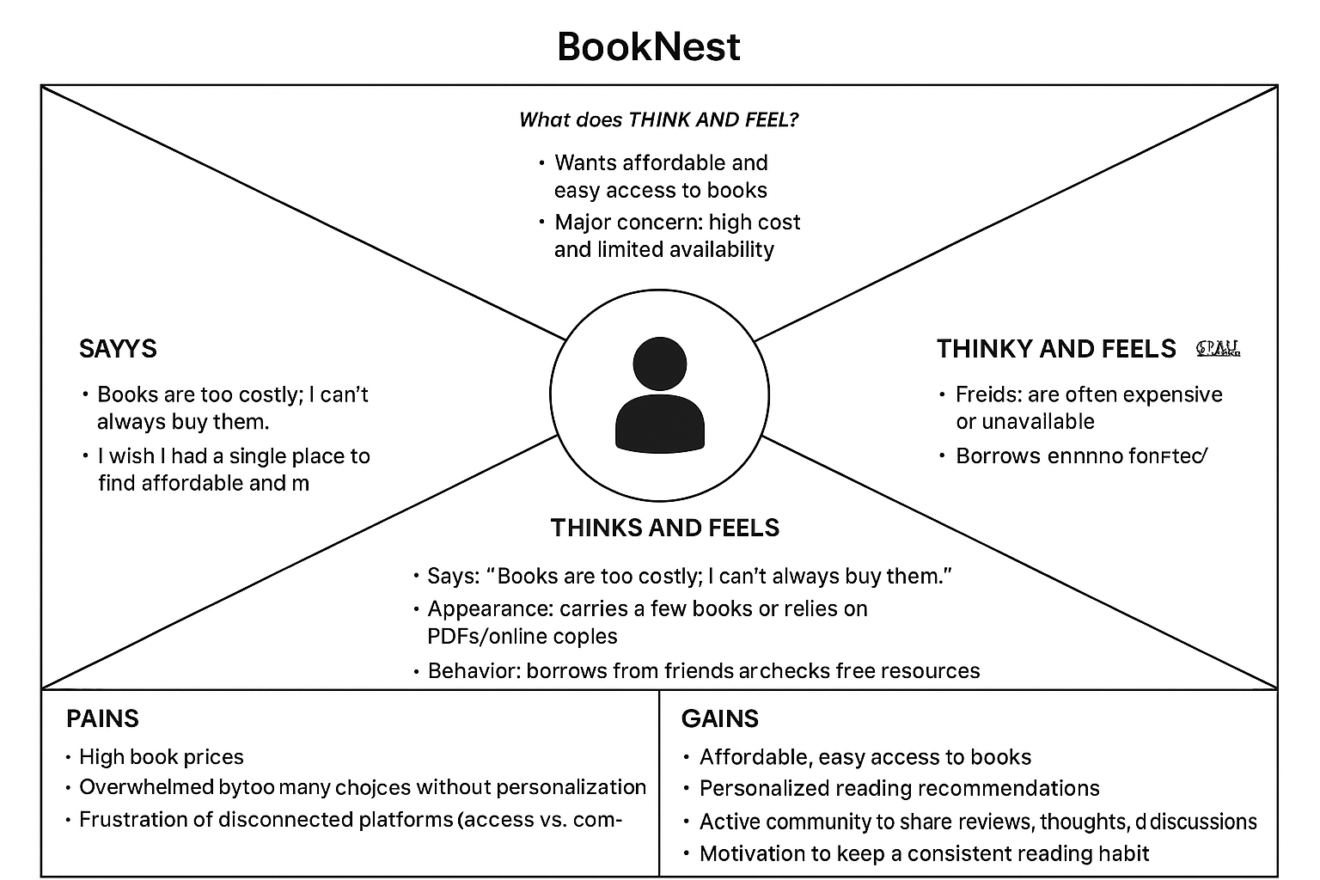

**Example: book Ordering & Delivery Application**

